Note to Participant: Below, find a template that will assist you in documenting the information provided and the supporting screenshots you should obtain during the purchasing process walkthrough.

Note that the only client attendee for this walkthrough is Jamie Blake (Purchasing Department Manager), and your Audit Senior (Kim) is the only other audit team member in attendance.

To completely document the walkthrough, note the walkthrough date, time, attendee details, and the purpose/procedure at the top of this workpaper.

As the walkthrough occurs, results should be documented under the subheadings (e.g., Purchase Policy, submitting a purchase request, etc.). Also, document screenshots of the Purchase Request Portal should where applicable.

Record responses to our list of client questions in line with the questions (already represented in Part B of this template) during that phase of the walkthrough.

Finally, based on the information gathered, note a conclusion for the walkthrough performed.

Date & Time Walkthrough Performed: | 11/01/2026
Client Attendees (including Role): | Jamie Blake (manager- Purchasing Department)
Audit Team Attendees: | Arghyajyoti Samui (Audit Member), Kim (Audit Senior)

Purpose/Procedure: The purpose of the walkthrough is to better understand the client policy for Purchasing and Procurement, functioning of the Purchase Portal, update on the organizational chart and to get response of the follow up questions.

Results: Understood Purchasing Policy of ABC Company, the process of Submitting a Purchase Request and its different workflow, the Approval Process, Making a Purchase, the Archived Records, Organizational Chart. Got response for most of the follow-up question. Follow up needed with IT and HR Department for the response of the rest of the question on portal and organizational changes and update and portal maintainence.

- Walkthrough of Purchase Request Portal:

- Purchase Policy
The Purchasing Policy is reviewed annually by the Risk Management Department at the end of June. Any updates are submitted to the CFO for review and approval. Following approval, relevant changes are communicated to the IT Department for updates to the Purchase Request Portal, if required. The approved policy is published on the company-wide shared drive and made accessible to all employees. Employees are required to acknowledge receipt of the updated policy and complete a quiz to confirm understanding of the purchasing process.
Key Controls Identified:
- Annual policy review performed by Risk Management.
- CFO review and approval required before implementation.
- Communication of policy changes to IT for portal updates.
- Publication of approved policy on shared drive accessible to all employees.
- Mandatory annual employee acknowledgment of policy receipt.
- Required employee training/quiz to confirm policy understanding.

- Submitting a Purchase Request
Employees are required to review the Purchasing Policy to determine whether their purchase exceeds the approval threshold ($5,000 for Associates/Senior Associates and $10,000 for Managers and above). If approval is required, the employee submits a purchase request through the Purchase Request Portal by entering required information, including requestor details, role, level, request date, purchase type, vendor, and estimated purchase value. The portal contains automated validation controls that prevent submission of incomplete requests. Upon successful submission, the request is automatically routed to the employee’s direct supervisor for review, and the request can be tracked through the "My Open Requests" section of the portal.

- Purchase Review/Approval Process
Once a purchase request is submitted, the Purchase Request Portal automatically routes the request to the employee's direct supervisor based on the organizational hierarchy and sends an automated email notification to the reviewer. The supervisor accesses the request through the portal, reviews the submitted details, and either approves or denies the request. For denied requests, the reviewer may provide a reason for rejection. After the decision is submitted, the portal sends an automated email notification to the requestor communicating the approval or denial outcome. Approved requests authorize the employee to proceed with the purchase from the selected vendor.

- Making a Purchase
Employees must obtain documented pre-approval for purchases that exceed the approval thresholds defined in the Purchasing Policy before submitting orders to external vendors. After receiving approval through the Purchase Request Portal, the employee may proceed with the purchase. Employees are responsible for ensuring that no purchases are made on behalf of the company without the required prior approval.

- Archived Records
The Purchase Request Portal maintains an archive of all reviewed purchase requests, including both approved and denied requests. Employees can access these records through the "Archived Records" view within the portal after logging in. Archived requests are stored in chronological order based on the purchase request date, and the portal has the capacity to retain all purchase requests submitted through the system.

- Table of Employee Supervisors (Org Chart within Portal)
The Purchase Request Portal uses a Table of Employee Supervisors (organizational chart) to automatically route purchase requests to the appropriate direct supervisor for review and approval. Following the annual promotion cycle, the HR Department provides an updated organizational chart to the IT Department within five business days. IT team leads update the supervisor table within the Portal's Administrative View, perform testing to verify accuracy, and save the changes to activate the updated reporting structure. The table is then locked to prevent unauthorized modifications.

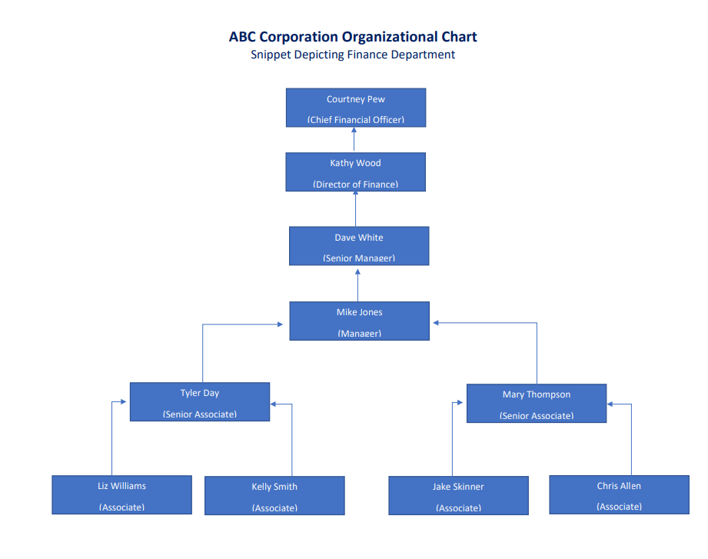

- Open Questions Follow-Up:
- Process & Control Changes (Which Have Occurred Since Prior Year Audit Period):
- Please confirm whether the process to review and update the Purchase Policy is the same as in the prior audit period.
RESPONSE- Confirmed

- What are the changes to Purchase Request Portal during the audit period (i.e., planned maintenance, as a result of the most recent Purchasing Policy update cycle, etc.)?
RESPONSE- The Purchase Request Portal (and associated process) went live during the last audit period, with no major issues or changes since initial implementation.

- Have there been any changes to key personnel (as they relate to the purchasing process and controls during the audit period)?
RESPONSE- No major changes to the personnel associated with the purchasing process occurred during the current audit period. I believe that it’s the HR Department’s policy to notify the IT Team immediately when employees are hired or leave the company. Then, the IT Department team leads implement the change immediately/directly to the Purchase Request Portal’s Table of Employee Supervisors. Please confirm with those teams.

- If so, when did those changes occur, and how were respective systems/processes updated?
RESPONSE: follow-up with the HR and IT Departments for further detail

- Purchase Request Portal:
- Portal Issue Reporting:
- How are issues with the Portal typically identified/reported?
RESPONSE- End-users of the Portal can escalate any issues directly to the IT Department.

- Who are issues reported to?
RESPONSE- End-users of the Portal can escalate any issues directly to the IT Department.

- How do stakeholders know where to report issues?
RESPONSE- The IT Department handles all internal software issues, and a direct line for issue reporting is disseminated via posting within various internal sites

- What is done after an issue is reported?
RESPONSE- The IT Department would be better suited to answer this question

- How often is the Purchase Request Portal tested?
RESPONSE: The IT Department (and the Internal Audit team) would be better suited to answer this question. The following two questions can also be directed to those teams.

- Who performs those tests?
RESPONSE: The IT Department (and the Internal Audit team) would be better suited to answer this question. The following two questions can also be directed to those teams.

- What were the results of the last test(s) performed?
RESPONSE: The IT Department (and the Internal Audit team) would be better suited to answer this question. The following two questions can also be directed to those teams.

- Purchase Approval Assignments (System Maintenance):
- How is the organizational chart within the Portal updated for each promotion cycle?
As per narrative: Following the annual promotion cycle, the HR Department provides the updated organizational chart to the IT Department. IT team leads access the Administrative View of the Purchase Request Portal, update the Table of Employee Supervisors, perform testing to verify accuracy, and save the changes to activate the revised reporting structure.

- Who is assigned responsibility to make those updates?
As per narrative: The IT Department team leads are responsible for updating and testing the organizational chart within the Purchase Request Portal. The HR Department is responsible for providing the updated organizational chart information.

- When are they performed?
As per narrative: Updates are performed annually, within five business days following the end of the company's annual promotion cycle, as required by internal policy.

- What documentation exists to verify that the control was performed in a complete and timely manner?
RESPONSE- Please follow-up with the IT Department for their process details

- Approved Vendor Listing:
- Does ABC Company employ an Approved Vendor Listing (to ensure employee purchases are only made to approved vendors)?
RESPONSE- No, however, vendors are reviewed as part of the purchase review/approval process

- How does ABC Company ensure that the purchases are made to third-party (unrelated) vendors?
RESPONSE- No, however, vendors are reviewed as part of the purchase review/approval process

- Prior-Year Exception(s) Follow-up:
- Last year, an issue was identified in some purchase approval documentation not being able to be retrieved/provided for audit support purposes (Noted that these exceptions occurred before the Purchase Request Portal was phased in).
RESPONSE- As stated during the walkthrough, all historical purchases/denials are retained by the Purchase Request Portal. The prior year exception was noted in our process before the Portal “went live” during that audit period.

Please explain the Purchasing Portal process to retain/archive the electronically provided approvals, including:
- How long is the approval archived within the system?
RESPONSE- Perpetually (all records of purchase approval/denial will be retained)

- In what instances (if any) can data be retroactively altered (i.e., to pre-date approvals)?
RESPONSE- Portal locks requests and results of review from alteration as soon as reviewer submits response. No archived records can be adjusted

- What are the controls surrounding access for the documented approvals?
RESPONSE- The “Archived Records” view within the portal allows for an employee to see all of their own purchase requests. For assigned reviewers, personnel can also access any purchase for which they reviewed and approved/denied.

- Approval Timing:
- What controls exist to ensure an employee does not externally submit a purchase to a vendor without the prerequisite, documented approval of such purchase?
RESPONSE- As per the required internal training and attestation surrounding the purchasing process (discussed earlier in this walkthrough), all employees agree to comply with the Purchasing Policy, including obtaining the required pre-approvals before a purchase on behalf of the company is made.

- Disclosure of Issues Which Occurred During the Audit Period:
- Have there been any issues of control gaps (i.e., points in the purchasing process in which an appropriate control did not adequately cover risks)?
RESPONSE- No such issues noted during the audit period

- Have there been any issues in control functionality (i.e., controls did not function as designed and therefore did not identify issues for which the control was designed to detect/prevent)?
RESPONSE- No such issues noted during the audit period

- Has your team identified any purchases submitted to the vendor before obtaining the required approvals (per the Purchasing Policy)?
RESPONSE- No such issues noted during the audit period

- Internal Reviews (of Purchasing Process & Controls) Performed During Audit Period:
- Have there been any internal reviews (i.e., client’s internal audit team reviewed process/controls, finance team reviewed process/controls, etc.) which cover the current audit period?
- How often are the purchasing process controls reviewed/tested/updated?
- When did the last updates to these controls occur?
- When did the last internal tests of these controls occur (please provide supporting documentation)?
- Have any instances of control gaps or failures (i.e., where a control failed to identify an issue or inaccuracy in the purchasing process or where a control area was identified for enhancement)?
RESPONSE: The IT Department (and the Internal Audit team) would be better suited to answer this question. The following two questions can also be directed to those teams.

- Initial (Drafted) Exceptions Noted as a Result of Current Year Fieldwork Performed:
- Purchase approval obtained from an employee other than the requestor’s direct supervisor
RESPONSE- Based on my research, it appears that an intra-year re-assignment of personnel was not captured in a timely manner within the Portal, and caused the previous direct supervisor of the requester to be assigned to the purchase request review

- Purchase was made with vendor before required pre-approval was obtained
RESPONSE- I followed-up with the purchaser and she noted that the exception was the result of making a reservation which was urgent in nature (specifically, to reserve a venue for the company’s holiday party)

Conclusion:
Based on the walkthrough performed, the purchasing process is supported by a formal Purchasing Policy and an automated Purchase Request Portal designed to facilitate, document, and retain purchase approval activities. Key controls observed include annual policy review and approval by the CFO, automated routing of purchase requests to direct supervisors based on the organizational hierarchy, system-enforced validation of required fields, automated approval/denial notifications, and perpetual retention of purchase approval records within the Portal.

Management confirmed that the purchasing process and related controls remained substantially consistent with the prior audit period, with no significant changes to the Purchasing Policy review process, Portal functionality, or key personnel involved in the process. The Portal continues to serve as the primary mechanism for documenting and retaining purchase approval evidence, addressing prior-year concerns regarding documentation retention.

No control gaps, control failures, or instances of purchases being made without required approval were reported during the audit period.
However, fieldwork identified isolated exceptions, including
(1) A purchase approval obtained from an employee who was no longer the requestor's direct supervisor due to an organizational chart update not being completed in a timely manner
(2) A purchase that was initiated prior to receiving documented approval due to an urgent business need. Management provided explanations for both exceptions.

Overall, the purchasing process appears to be appropriately designed and supported by automated controls within the Purchase Request Portal. Subject to the evaluation of the identified exceptions and any follow-up procedures with the IT, HR, and Internal Audit teams, no systemic issues were noted that would indicate a breakdown in the overall design or operation of the purchasing approval process.

